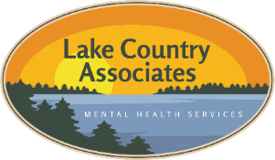
Lake Country Associates
515 Bridge St, Park Rapids MN 56470 Phone:218-366-9229 Fax: 218-237-2520
615 Anne Street NW, Suite A, Bemidji MN 56601 Phone:218-444-2233
11 Main St E, Menahga MN 56164

Referral Form

Name of person making referral: Date:
Agency:
Client Name: Date of Birth:
Male Female If minor, name of legal guardian:
Client/guardian Home # Cell #
Best Time to Contact:
Client Address:

Services Requested Initial Assessment Resume therapy Crisis
Psychological Testing Other
Describe concerns:

Primary insurance __ Secondary insurance

***Before cutting, fax this form and Release of Information to LCA at 218 237-2520***

Cut Here and give to patient - - - - - - - - - -

APPT SCHEDULED WITH: Date/Time:
Lake Country Associates, Inc.
Mental Health Services
515 Bridge St East / PO Box 806
Park Rapids, MN 56470
218 366-9229
* Please arrive 30 minutes prior to your
Grove St North appointment to complete paperwork.
* Please bring your insurance card and
Hwy 34 East a printout of your current medications.
river * Cancellations require 24-hour notice

